QueryLens:

A Validation-Aware SQL Query Analysis Tool for Performance Optimization

Parshotam Parmar
A00590956
COMP8047 Major Project
British Columbia Institute of Technology
Date: April 22, 2026

Contents
1. Introduction 3
1.1 Project Context 3
2. System Design 4
2.1 SQL Parsing and Feature Extraction 5
2.2 Static Analysis Engine 5
2.3 Execution Plan Analysis 5
2.4 Correlation and Validation Engine 6
2.5 Reporting and Artifact Generation 6
2.6 Alternative Approaches 6
2.7 Feasibility Assessment 7
2.8 Use of Technologies 7
2.9 Evolution of Deliverables from Proposal 8
3. Implementation 9
3.1 Static Analysis Implementation 9
3.2 Runtime Analysis Implementation 9
3.2.1 Live Execution Plan Capture 9
3.3 Correlation Engine Implementation 10
3.4 System Usage 10
4. Evaluation 12
4.1 Evaluation Environment 13
4.2 Overall Performance 13
4.3 False Positive Reduction 14
4.4 Precision Improvement 14
4.5 Ground Truth Validation 14
4.6 Rule-Level Performance 14
4.7 Validation Examples 15
5. Discussion 17
5.1 Strengths 17
5.4 Timeline and Milestones 18
6. Conclusion 19
7. Professional and Academic Development 20
8. Lessons Learned 20
Appendix A — Approved Proposal 20
Appendix B — Proposal Changes and Approvals 21
Appendix C — Change Log 21
References 21

1. Introduction
Modern database-driven applications depend heavily on efficient SQL query execution to ensure scalability and responsiveness. However, identifying performance issues in SQL queries remains a challenging task, particularly for developers who lack visibility into how queries behave at runtime. Traditional approaches to query analysis often rely on either static code inspection or runtime execution plan analysis but rarely integrate both perspectives in a unified framework.
Static analysis tools can identify common anti-patterns such as non-SARGable predicates, excessive data retrieval, and inefficient joins. However, these tools frequently generate false positives because they lack awareness of actual execution behavior. In contrast, execution plan analysis provides detailed insights into runtime performance but does not inherently explain the underlying causes of inefficiencies in the original SQL code. As a result, each approach offers only a partial view of query performance when used in isolation.
This project introduces QueryLens, a validation-aware SQL query analysis tool designed specifically for Microsoft SQL Server. QueryLens integrates grammar-based static analysis with execution plan evaluation to produce more accurate and actionable performance recommendations. By correlating static warnings with runtime evidence, the system reduces false positives and improves the reliability of optimization suggestions.
The motivation for this project stems from real-world experience working with SQL Server databases in a production environment, where inefficient queries and stored procedures frequently caused performance bottlenecks. Existing tools often produced noisy or incomplete recommendations, making it difficult to prioritize optimization efforts. QueryLens addresses this gap by combining static and runtime analysis into a single, coherent system.
The primary objective of this project is to demonstrate that integrating execution plan validation into static SQL analysis significantly improves precision and reduces false positive recommendations. Unlike conventional tools, QueryLens does not treat static and runtime analysis as independent processes but instead integrates them into a validation-aware framework that prioritizes confirmed inefficiencies over theoretical risks.

1.1 Project Context
QueryLens was developed in the context of SQL Server–based business systems where application performance is closely tied to database query quality. In transactional environments, small inefficiencies in query design can produce noticeable slowdowns when repeated across high-volume workloads. This project is especially relevant to operational systems such as point-of-sale platforms, where delays in transaction processing, reporting, or database access can directly affect users and business workflows.
The project is also grounded in practical industry experience. Performance issues observed in production SQL Server environments frequently originated from patterns such as unnecessary column retrieval, non-SARGable predicates, poorly selective joins, and inefficient report queries. Although SQL Server exposes detailed execution plans, interpreting those plans requires a level of database tuning expertise that is not always available to software developers or support analysts. QueryLens was therefore designed to bridge this gap by turning execution plan evidence into understandable, development-oriented feedback.
Within this operational context, the project addresses a real need: enabling earlier and more consistent identification of SQL performance risks before they escalate into production bottlenecks. QueryLens supports this goal by integrating static query inspection with runtime validation, allowing likely inefficiencies to be distinguished from confirmed performance issues.

2. System Design
QueryLens is implemented as a multi-stage analysis pipeline, where each component produces structured artifacts consumed by subsequent stages. This design enables traceability between static detections, runtime validation, and final recommendations.
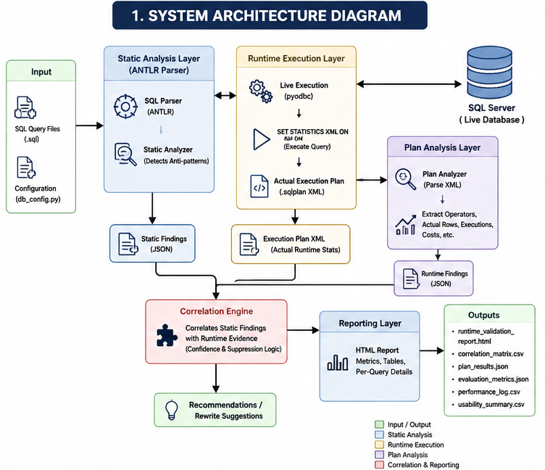
Figure 1: High-level QueryLens system architecture showing SQL parsing, static analysis, runtime execution-plan analysis, correlation validation, and artifact generation workflow.
The system consists of the following key components:

2.1 SQL Parsing and Feature Extraction
QueryLens uses an ANTLR-based T-SQL grammar to parse SQL queries into abstract syntax trees (ASTs). This grammar-aware approach enables accurate detection of query structures such as joins, subqueries, aggregations, and predicate expressions. A feature extraction module traverses the AST to identify relevant characteristics used for rule evaluation.

2.2 Static Analysis Engine
The static analysis component evaluates extracted features against a set of predefined rules representing common SQL performance anti-patterns. These include:
- Use of SELECT *
- Non-SARGable predicates (e.g., functions on indexed columns)
- ORDER BY operations without supporting indexes
- Complex joins and correlated subqueries
- Window functions and derived tables
Each detected issue is recorded as a structured finding with associated metadata and recommended optimizations.
QueryLens supports multi-rule detection, allowing a single SQL query to trigger multiple performance warnings, each independently validated against runtime evidence.

2.3 Execution Plan Analysis
Execution plans generated by SQL Server are parsed to extract runtime characteristics, including:
- Physical operators (e.g., Index Scan, Index Seek, Sort, Hash Match)
- Logical operators
- Estimated row counts
- Actual row counts
- Actual execution counts
- Join strategies and aggregation operations
- Estimated subtree cost
Unlike the initial prototype design, the final version of QueryLens supports both offline execution-plan analysis and live execution-plan capture through direct SQL Server integration using pyodbc. Live execution plans are generated dynamically using SQL Server’s SET STATISTICS XML ON functionality, allowing QueryLens to retrieve actual runtime execution metrics directly from query execution.
This execution-plan evidence allows the system to evaluate how queries behave during execution rather than relying solely on static SQL inspection. Runtime features extracted from plans are used to validate static findings, suppress unsupported warnings, and strengthen confidence scoring for confirmed performance issues.
Actual runtime statistics such as actual row counts and actual operator executions significantly improve the reliability of runtime validation because they provide direct evidence of query behavior under execution.

2.4 Correlation and Validation Engine
The core innovation of QueryLens lies in its correlation engine, which links static warnings to execution plan evidence. Each rule is classified as either runtime-verifiable or non-verifiable. For verifiable rules, the system evaluates whether execution plan characteristics support or contradict the static finding.
A confidence scoring mechanism assigns levels (high, medium, low, none) based on the strength of runtime evidence. Static findings that lack supporting evidence are suppressed, reducing false positives.

2.5 Reporting and Artifact Generation
The system produces a comprehensive set of artifacts, including:
- Structured JSON outputs for static and runtime analysis
- Evaluation metrics and correlation matrices
- False positive analysis logs
- HTML reports summarizing findings and recommendations
This layered output structure ensures transparency and facilitates further analysis.

2.6 Alternative Approaches
Several alternative approaches were considered before selecting the final design of QueryLens.
The first alternative was a static-only SQL analysis tool. This approach would examine SQL text for known anti-patterns such as SELECT *, functions in predicates, and complex joins, but would not consider execution plan behavior. A static-only solution would be simpler to implement and faster to run, but it would also produce a higher number of false positives because it would not be able to determine whether a detected issue affected execution behavior.
A second alternative was an execution-plan-only analyzer. This approach would focus entirely on SQL Server XML plans and operator-level behavior, such as scans, seeks, sorts, and joins. While this would provide strong runtime visibility, it would not explain the corresponding code-level source of inefficiencies. Such a system would be useful for database specialists, but less accessible to developers who need direct guidance about how to improve the original SQL text.
A third alternative was to rely on existing tools such as SQL Server Management Studio or standalone linting utilities. These tools provide partial support for performance analysis but typically emphasize either runtime diagnostics or code inspection rather than combining both in a single validation-aware workflow. They also tend to require significant manual interpretation and do not always prioritize issues according to supporting execution evidence.
For these reasons, the selected solution was a hybrid validation-aware analysis system. By combining static SQL analysis with execution plan correlation, QueryLens was designed to preserve the interpretability of code-level diagnostics while improving accuracy through runtime confirmation. This approach best aligned with the project’s practical objective of reducing false positives and producing more reliable recommendations.

2.7 Feasibility Assessment
The feasibility of QueryLens was evaluated in technical, operational, and schedule terms.
From a technical feasibility perspective, the project was practical because all core technologies were available and well supported. Python provided a flexible environment for pipeline orchestration and artifact generation. ANTLR supplied a mature grammar-based parsing framework for T-SQL analysis, and SQL Server execution plans could be exported in XML format for deterministic parsing. The modular nature of the problem also made the system suitable for staged development, beginning with simple static rule detection and expanding toward runtime validation and reporting.
From an operational feasibility perspective, the required environment was modest and already available. Development and testing were performed on a single workstation using SQL Server Developer Edition, local datasets, and pre-generated execution plans. No external infrastructure, cloud services, or production data were required. This reduced both risk and implementation overhead.
From a schedule feasibility perspective, the project was manageable because it could be divided into incremental milestones. Early weeks focused on execution plan parsing and dataset engineering, followed by static analysis, correlation logic, evaluation, and reporting. This staged approach made it possible to validate progress continuously and reduce the risk of major late-stage integration failures. Over the course of development, the project expanded from prototype components into a consolidated end-to-end system totaling approximately 397 hours of effort.
Overall, QueryLens was feasible because it addressed a clearly bounded problem, used accessible technologies, and could be implemented iteratively with measurable intermediate deliverables.

2.8 Use of Technologies
QueryLens incorporates several technologies that were selected specifically to support accurate, reproducible SQL performance analysis.
The first key technology is ANTLR, which was used to support grammar-aware parsing of T-SQL queries. Rather than relying only on regular-expression heuristics, the use of ANTLR allowed QueryLens to parse SQL into abstract syntax trees and inspect structural features such as joins, subqueries, HAVING clauses, window functions, and derived tables. This provided greater precision and extensibility in rule detection.
The second key technology is SQL Server execution plan analysis. QueryLens parses SQL Server XML plan files to extract runtime evidence including scans, seeks, joins, sorts, parallelism operators, estimated row counts, actual row counts, and actual execution counts. This allows the system to move beyond purely theoretical warnings and instead assess whether static findings are supported by observed execution behavior.
The third important technology is pyodbc, which provides direct SQL Server connectivity. QueryLens uses pyodbc to establish live database connections, execute workload queries safely, and dynamically retrieve actual execution plans through SQL Server’s SET STATISTICS XML ON functionality. This integration enables the system to automatically generate execution plans and collect actual runtime statistics without requiring manual plan export.
The fourth important technical element is the system’s validation-aware correlation engine, which links code-level detections to execution-plan evidence. This correlation layer represents the main research and implementation contribution of the project because it enables selective confirmation, suppression, and confidence scoring of findings.
Finally, QueryLens uses structured artifact generation and reporting to ensure reproducibility. JSON, CSV, and HTML outputs are produced from the same core pipeline, making the system suitable both for experimentation and for end-user diagnostic reporting.
Together, these technologies support the project’s goal of producing a practical and evidence-based SQL performance analysis tool rather than a static linter or a plan viewer alone.

2.9 Evolution of Deliverables from Proposal
The original project proposal defined a set of core artifacts to support static analysis, execution plan parsing, and report generation. During implementation, these artifacts were refined and expanded to support validation-aware evaluation and reproducibility.
Several proposed artifacts were reorganized into a structured directory hierarchy to improve clarity and maintainability. For example, analysis outputs such as static_results.json and plan_results.json were moved into a dedicated artifacts/analysis/ directory, while evaluation outputs were grouped under artifacts/evaluation/.
In addition to restructuring, new artifacts were introduced to support the validation-aware design of QueryLens. These include correlation matrices, false positive validation logs, performance benchmarking outputs, and comparison artifacts demonstrating improvements over static-only analysis. These additions were necessary to provide empirical evidence supporting the project’s primary objective of reducing false positives and improving diagnostic precision.
The final system therefore extends the original proposal by not only generating diagnostic outputs but also producing a comprehensive set of evaluation artifacts that enable reproducible experimentation and quantitative analysis. These enhancements do not change the core objectives of the project but strengthen the evaluation methodology and improve the transparency of results.

3. Implementation
QueryLens is implemented in Python and follows a modular architecture to ensure maintainability and extensibility.

3.1 Static Analysis Implementation
Static analysis is performed using an AST-based approach rather than regular expressions, improving detection accuracy and reducing ambiguity. Unit testing confirms the correctness of rule detection across all supported patterns, with all tests passing successfully.

3.2 Runtime Analysis Implementation
Runtime analysis is performed through a combination of execution-plan parsing and live SQL Server integration.
QueryLens supports both offline execution-plan analysis using stored .sqlplan files and live execution-plan capture through pyodbc database connectivity. In live mode, workload queries are executed directly against SQL Server using a controlled validation dataset. Execution plans are captured automatically using SQL Server’s SET STATISTICS XML ON functionality.
To ensure safe execution behavior, QueryLens restricts live execution to read-only SELECT-style workload queries. Queries containing potentially destructive operations such as INSERT, UPDATE, DELETE, DROP, ALTER, MERGE, or TRUNCATE statements are automatically rejected.
Captured execution plans are parsed to extract operator-level runtime details including:
- scans
- seeks
- sorts
- joins
- hash aggregations
- estimated row counts
- actual row counts
- actual operator executions
- estimated subtree costs
Actual runtime statistics are used preferentially when available, while estimated metrics are retained as fallback behavior for offline execution plans that lack runtime counters.
The system dynamically generates .sqlplan files during execution and stores them in a dedicated plans_live/ directory. This allows the complete runtime-validation workflow to be reproduced from workload SQL files alone.

3.2.1 Live Execution Plan Capture
A significant enhancement introduced during the later stages of development was live execution-plan capture through direct SQL Server integration.
QueryLens uses pyodbc to establish a live SQL Server connection and execute workload queries against the validation dataset. Before execution, the system validates queries to ensure that only read-only SELECT-style workloads are permitted. This prevents accidental execution of destructive SQL statements.
Execution plans are retrieved dynamically using SQL Server’s SET STATISTICS XML ON functionality. After query execution completes, QueryLens extracts the generated XML execution plan and stores it automatically in the plans_live/ directory.
Unlike estimated execution plans alone, live execution plans include runtime execution statistics such as actual row counts and actual operator execution counts. These runtime statistics significantly improve the quality of validation-aware correlation because the system can evaluate observed execution behavior rather than relying solely on estimated optimizer predictions.
This enhancement removed the earlier requirement for users to manually export execution plans and substantially improved the automation and practicality of the QueryLens workflow.

3.3 Correlation Engine Implementation
The correlation engine evaluates each static finding against runtime evidence. For example:
- A SELECT * warning is confirmed if scans and large row counts are present
- A missing WHERE warning may be suppressed if runtime evidence does not indicate inefficiency
- False positive logs demonstrate that several static warnings were correctly suppressed due to insufficient runtime evidence, improving overall accuracy.

Rewrite suggestions are generated only after correlation analysis, allowing QueryLens to prioritize recommendations supported by execution-plan evidence rather than static detection alone.

3.4 System Usage
QueryLens is designed to operate as a validation-aware batch analysis system over a workload of SQL files.
To run the complete system, the user executes the main pipeline command:
python -m src.run_full_analysis
The pipeline processes all SQL workload files and executes the following stages:
- static SQL analysis
- feature extraction
- live or offline execution-plan analysis
- static/runtime correlation
- rewrite suggestion generation
- evaluation artifact generation
- report generation
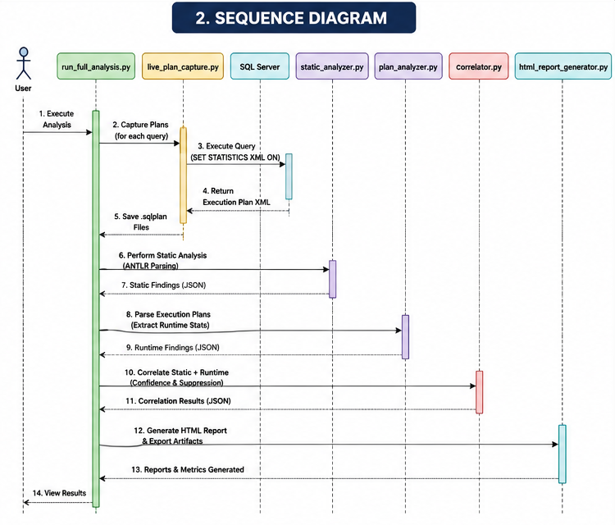
QueryLens supports two execution modes.
Offline Mode
In offline mode, the system analyzes:
- .sql workload files
- matching .sqlplan execution plans
This mode supports reproducible experimentation without requiring a live SQL Server connection.
Live Mode
In live mode, QueryLens automatically connects to SQL Server through pyodbc and dynamically generates execution plans during query execution. In this configuration, only workload .sql files are required because execution plans are captured automatically using SQL Server’s runtime statistics functionality.
Live execution plans are written to the plans_live/ directory and include actual runtime metrics such as actual row counts and actual execution counts.
The main outputs are written to the artifacts/ directory. These include structured analysis results in JSON format, evaluation metrics in JSON and CSV formats, performance logs, usability summaries, correlation matrices, comparison artifacts, and a human-readable HTML validation report.
This workflow allows the system to be reproduced from a single command and supports consistent experimentation across the benchmark workload.

4. Evaluation
The system was evaluated using a controlled experimental methodology designed to assess the effectiveness of validation-aware SQL analysis. A workload of 30 SQL queries was constructed to represent a range of realistic database scenarios, including joins, aggregations, subqueries, and indexing patterns. For each query, a corresponding SQL Server execution plan was generated and analyzed alongside static detection results.
Testing was performed using a reproducible batch pipeline that applies static analysis, execution plan parsing, and correlation-based validation across the entire workload. Evaluation metrics were derived by comparing static warnings against runtime evidence to measure confirmation rates, false positive reduction, and precision improvement. All experiments were executed using stored inputs and execution plans, ensuring consistency and repeatability of results.
The evaluation process produced structured artifacts including validation reports, correlation matrices, performance logs, and comparison summaries, which were used to support analysis and ensure traceability of results.

4.1 Evaluation Environment
Evaluation was performed on a Windows-based local development environment using Microsoft SQL Server 2019 Developer Edition and Python 3.11.9. QueryLens was executed using live SQL Server integration through pyodbc with ODBC Driver 17 for SQL Server. Testing used a controlled synthetic validation dataset containing Customers, Orders, Products, and OrderItems tables populated with high-volume benchmark data. All experiments were executed on a single workstation to ensure reproducibility and consistency across evaluation runs.

4.2 Overall Performance
The analysis produced 55 static warnings, of which 35 were runtime verifiable. Among these, 32 warnings were confirmed by execution-plan evidence, resulting in a runtime agreement rate of 91.4%.
The final validation-aware pipeline also produced:
- 21 high-confidence confirmations
- 3 suppressed findings
- 118 runtime operators extracted from execution plans
- approximately 10.7 seconds total batch runtime during live execution-plan capture mode
These results demonstrate that combining static SQL analysis with runtime validation substantially improves diagnostic precision while maintaining reproducible evaluation behavior.
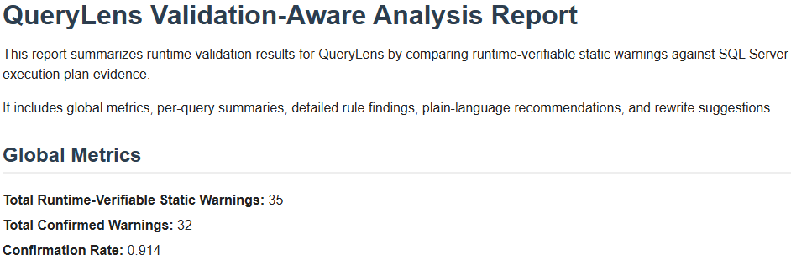
Figure 2: QueryLens runtime validation report showing per-query analysis results, validation status, and confidence levels.

4.3 False Positive Reduction
Static-only analysis generated a large number of false positives. By incorporating runtime validation, QueryLens reduced false positives from 57 to 20, representing a 65% reduction. This demonstrates the effectiveness of combining static and runtime analysis.

4.4 Precision Improvement
The precision of the analysis improved significantly when runtime validation was applied. Static-only analysis resulted in low effective precision in practice, highlighting the limitations of unvalidated static detection, whereas the combined approach achieved 64.9% precision, representing a substantial improvement in recommendation quality.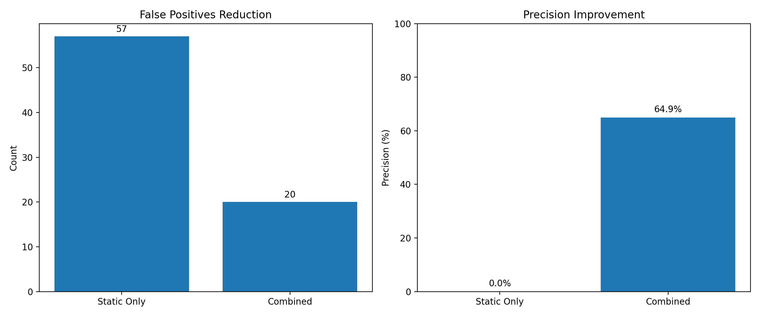
Figure 3: Comparison of static-only analysis and validation-aware QueryLens analysis, illustrating reduction in false positives and improved precision

4.5 Ground Truth Validation
When evaluated against a labeled dataset, QueryLens achieved exact performance on the labeled dataset:
- Precision: 1.0
- Recall: 1.0
- F1 Score: 1.0
These results are based on a controlled labeled dataset and reflect correctness of rule implementation rather than real-world detection completeness.

4.6 Rule-Level Performance
Certain rules demonstrated particularly strong performance:
- non_sargable_predicate: 100% precision
- order_by_no_index: 100% precision
- select_star: 90% precision
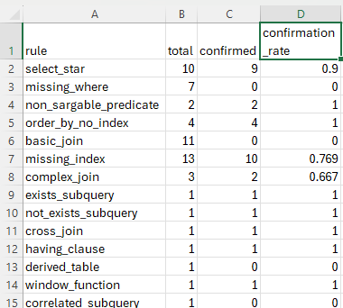
Figure 4: Rule-level correlation matrix summarizing confirmation rates between static detections and execution plan evidence.
In contrast, rules such as missing_where and basic_join were not runtime-verifiable and therefore required suppression logic to prevent misleading recommendations.

4.7 Validation Examples
To demonstrate practical validation behavior, QueryLens was evaluated against both optimized and intentionally inefficient SQL queries.
Good-query examples included sargable indexed filters that produced no unnecessary warnings or rewrite suggestions. For example:
SELECT CustomerID FROM Customers WHERE CreatedDate >= '2024-01-01';
This query generated no major recommendations because runtime evidence confirmed efficient index-seek behavior.
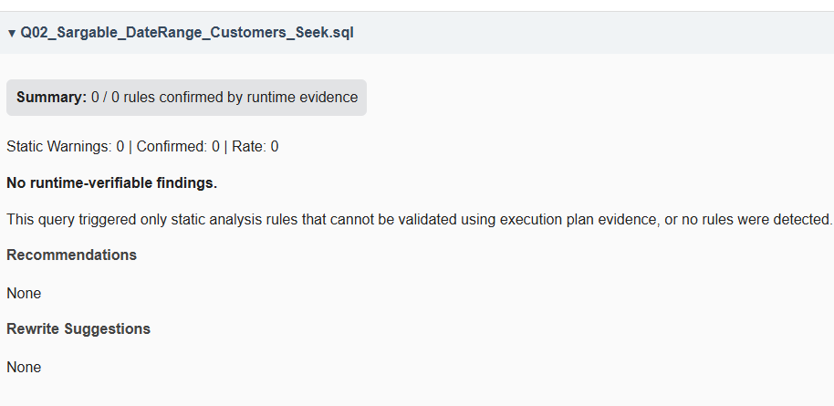
Bad-query examples included patterns such as SELECT *, non-SARGable predicates, and non-indexed ORDER BY operations.
For example:
SELECT * FROM Customers;
This query generated a confirmed select_star warning with high confidence due to scan evidence and large runtime row counts.
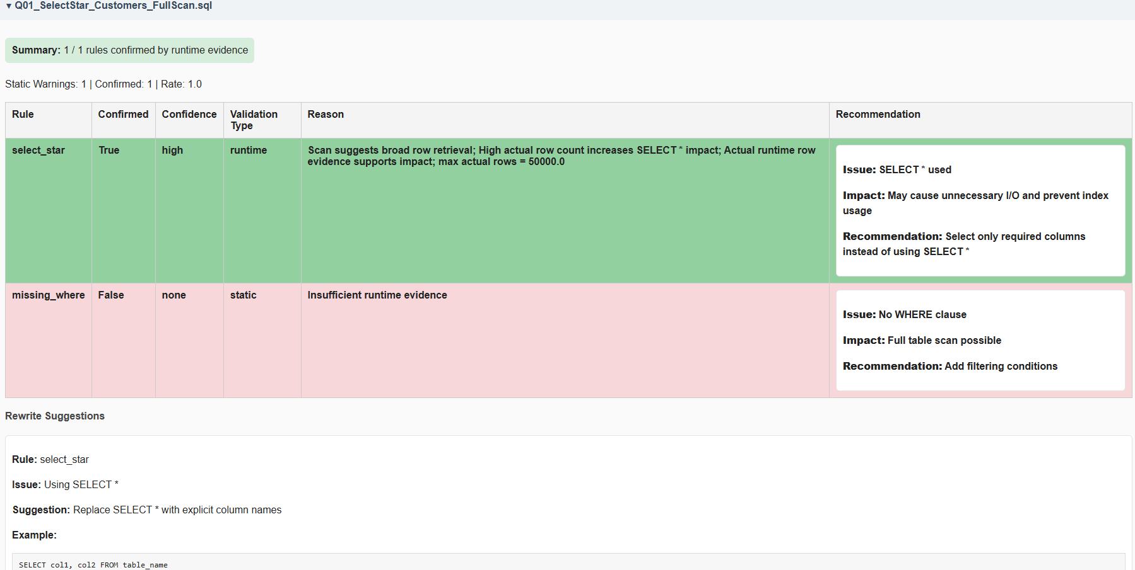
Similarly:
SELECT CustomerID FROM Customers WHERE YEAR(CreatedDate) = 2025;
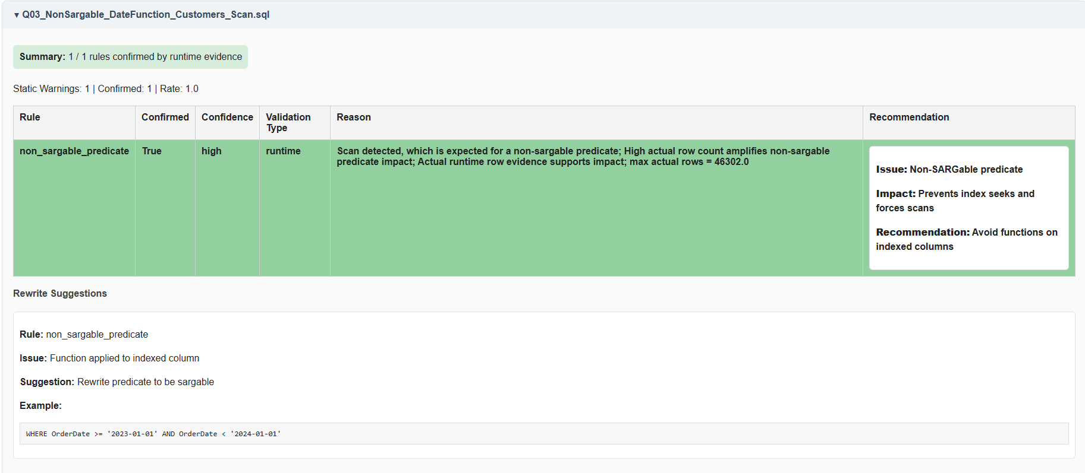
generated a confirmed non_sargable_predicate finding supported by scan behavior in the execution plan.
These examples demonstrate that QueryLens distinguishes between acceptable SQL patterns and performance risks rather than generating recommendations indiscriminately.

5. Discussion
The results demonstrate that integrating runtime validation into static SQL analysis significantly improves the quality of performance recommendations.

5.1 Strengths
The primary strength of QueryLens lies in its ability to reduce false positives while maintaining high detection accuracy. By grounding static findings in execution-plan evidence, the system provides more reliable and actionable insights.
A major strength of the final implementation is the integration of live SQL Server connectivity through pyodbc. This allows QueryLens to automatically capture execution plans, retrieve actual runtime statistics, and validate findings using real execution behavior rather than relying entirely on estimated execution metrics.
The system also demonstrates strong reproducibility through its structured artifact-generation pipeline, which automatically produces JSON, CSV, graphical, and HTML outputs from a single analysis workflow.
A key contribution of QueryLens is that unsupported static warnings are actively suppressed rather than merely reported, reducing noise and improving recommendation trustworthiness.
Finally, the modular architecture supports extensibility by separating parsing, static analysis, runtime analysis, correlation, reporting, and evaluation into independent components.

5.2 Limitations
Despite its strengths, the system has several limitations related to implementation scope and evaluation constraints.
First, QueryLens currently supports only Microsoft SQL Server. The parser, execution-plan analysis logic, and runtime validation workflow are tightly coupled to SQL Server execution-plan semantics and SQL Server XML plan formats. Supporting additional database systems such as PostgreSQL or MySQL would require substantial adaptation of both parsing and runtime-analysis components.
Second, while QueryLens supports live execution-plan capture and actual runtime statistics, the runtime-validation logic currently focuses on a selected subset of execution-plan operators and performance indicators. Additional operator coverage and deeper cost-based analysis could improve the granularity of runtime validation.
Third, the evaluation methodology focuses on agreement between static analysis and execution-plan evidence rather than absolute ground-truth correctness. Comprehensive ground-truth labeling for all possible SQL inefficiencies is not feasible, and therefore the system evaluates consistency and runtime confirmation rather than universal correctness.
Fourth, the evaluation dataset is synthetic, although designed to reflect realistic SQL Server workloads. While it captures a wide range of query patterns, it does not fully represent the complexity and variability of large-scale production systems.
Finally, the current implementation primarily evaluates standalone SQL workloads. Although the parser and analysis pipeline operate on T-SQL text and can therefore analyze stored procedure bodies, the system does not currently perform automatic database introspection or stored procedure extraction directly from SQL Server metadata.
These limitations reflect deliberate design trade-offs made to ensure feasibility, reproducibility, and controlled evaluation within the scope of the project.

5.3 Future Work
Future improvements could include:
- Expanding the rule set to cover additional SQL patterns
- Incorporating cost-based analysis using execution plan metrics
- Extending support to other database systems
- Integrating machine learning techniques for adaptive rule weighting

5.4 Timeline and Milestones
The development of QueryLens followed an incremental milestone-based schedule that allowed core components to be implemented and validated progressively.
The first phase focused on environment setup, execution plan parsing, and dataset preparation. This established the technical foundation of the project by configuring SQL Server, Python tooling, and the initial plan-analysis prototype. It also produced the baseline workload and seeded datasets required for later evaluation.
The second phase focused on static SQL analysis and parser integration. During this stage, the original heuristic analysis was refactored into a grammar-aware pipeline using ANTLR, and automated testing was introduced to validate rule detection.
The third phase emphasized runtime validation and evaluation design. This included development of the static/runtime correlation engine, generation of correlation metrics, false-positive diagnostics, and HTML reporting.
The fourth phase extended the project through expanded workload evaluation, rule refinement, and architectural consolidation. The benchmark workload was increased to 30+ queries, runtime confirmation logic was refined, and the evaluation workflow was standardized around the final validation-aware pipeline.
The final phase focused on recommendation generation, proposal traceability, and submission readiness. During this stage, rewrite suggestions were integrated, proposal-supporting artifacts were regenerated from the main pipeline, and the repository structure, documentation, and reporting outputs were finalized.
This milestone structure made it possible to progress from a narrow prototype into a fully integrated and reproducible analysis system while continuously validating intermediate results.
The development timeline is further supported by version-controlled commit history, where each milestone corresponds to a recorded weekly commit documenting implemented features, evaluation changes, and system refinements.

6. Conclusion
QueryLens demonstrates that combining static SQL analysis with execution plan validation provides a practical and effective approach to query performance optimization. The system successfully reduces false positives, improves precision, and delivers more reliable recommendations compared to static analysis alone.
By bridging the gap between code-level analysis and runtime behavior, QueryLens offers a valuable tool for developers and database administrators seeking to optimize SQL performance. The results of this project confirm that validation-aware analysis is a promising direction for future research and development in database performance tools.
This work demonstrates a practical and scalable approach to SQL performance analysis that can be extended to real-world development environments.

7. Professional and Academic Development
This major project significantly strengthened expertise in the database specialization by connecting theoretical concepts from coursework to the design of a practical software system. The project required applied use of SQL optimization principles, execution plan interpretation, parser design, rule-based analysis, evaluation methodology, and structured reporting. Through QueryLens, concepts such as non-SARGability, indexing strategy, join selectivity, and runtime operator behavior were translated from classroom topics into an implemented tool with measurable results.
The project also extended skills beyond traditional coursework by requiring the integration of multiple technical domains into a single end-to-end system. This included grammar-based parsing with ANTLR, structured artifact generation, experimental benchmarking, and evaluation of detection quality using both labeled datasets and runtime validation evidence. As a result, the project strengthened both technical specialization and systems-level design thinking.

8. Lessons Learned
Several lessons were learned during the development of QueryLens beyond what is typically covered in classroom exercises.
The first lesson was that accurate diagnostics require more than correct detection logic. Early static analysis components could successfully identify common SQL anti-patterns, but without runtime context they also produced unnecessary warnings. This reinforced the importance of evidence-based validation rather than relying solely on heuristic pattern matching.
The second lesson was that software architecture matters as much as algorithm design. As the project expanded, modularization, artifact organization, and pipeline consolidation became essential to keeping the system maintainable and reproducible. Refactoring and standardization were therefore not secondary cleanup tasks, but core parts of completing the project successfully.
The third lesson was that evaluation design is itself a major engineering task. Building a reproducible benchmark workload, generating comparable execution plans, constructing ground-truth datasets, and producing report-ready artifacts required substantial effort and careful methodological choices. This experience demonstrated that high-quality software projects depend not only on implementation, but also on the quality and transparency of their validation process.
Finally, the project reinforced the practical value of building systems around real operational problems. By grounding the work in realistic SQL Server performance issues, QueryLens became more than an academic prototype; it became a focused demonstration of how database expertise, software engineering, and evaluation discipline can be combined into a useful diagnostic tool.

Appendix A — Approved Proposal
A copy of the approved major project proposal should be included here.

Appendix B — Proposal Changes and Approvals
The core objectives of the project remained consistent with the approved proposal. However, several implementation refinements were introduced during development, including artifact restructuring, evaluation pipeline consolidation, and expansion of proposal-supporting outputs to improve reproducibility and evaluation transparency.

Appendix C — Change Log
Version | Date | Change Summary
1.0 | April 22, 2026 | Initial full draft of final report
1.1 | April 22, 2026 | formatting, evaluation clarification, guideline alignment
1.2 | May 15, 2026 | Added screenshots for reports, system/sequence diagrams, runtime validation report screenshot and sections for the pyodbc integration

References
Microsoft. Display an Actual Execution Plan. Microsoft Learn.
Grant Fritchey. SQL Server Execution Plans.
ANTLR grammars-v4 repository. T-SQL Grammar.
Python Software Foundation. Python Documentation.
Microsoft. SQL Server Query Processing Architecture Guide.

